**Psychology**

**Year Eleven – ATAR**

|  |  |
| --- | --- |
| Name: |  |
|  |  |
| Date: | Friday 19th June 2015 |
| Assessment Type: | Response |
| Outcome: | Outcome 1: Psychological understandings  Outcome 4: Communication in psychology |
| Unit Content: | Developmental psychology  Nature vs. nurture debate   * Twin studies * Adoption studies * Intelligences as measured by intelligence quotient (IQ) |

**TASK 1**

**Response**.

You are required to find a psychology journal article that explores the nature vs. nurture debate regarding intelligence **through a twin or adoption study**.

Based on this article, you will critique it using the attached literature review.

**Time for the task**

One week

**What you need to do**

Refer to the information contained in this brief

**This task is worth 7.5% of your course mark**

|  |  |
| --- | --- |
| **What needs to be submitted for this assessment?** | **Due date:** |
| 🞎 Written up questions in this booklet | Friday 19th  June, 2015 |
| 🞎 Written up questions in this booklet |

|  |  |
| --- | --- |
| Mark | 25 |
| Percentage | % |

This task provides an opportunity for you to source and review (via articles, reports, websites, books, newspapers) one document related to psychology and the ideas, topics, concepts, and theories you are studying about twin or adoption studies to consider intelligence as measured by IQ.

You will be asked to explore and reflect on the information presented in the document you select and complete a resource/literature review.

**The activity**

Source a psychological article regarding **intelligence as measured by IQ using a twin or adoption study**.

* Download the document and submit a copy of the article with your review.
* Evaluate your article by completing a formal review using this document ‘Literature Review Sheet’. ***Complete it on Word, save it as a PDF and eSubmit on Coneqt.***

**The timeframe**

You will have one week to complete this task including the sourcing and review of the document you source. Limited class time will be allocated to this task.

**The support**

You will be supported through this process in the following ways:

* by your teacher,
* being guided by the assessment criteria on the marking key
* by using the psychological materials that you have access to.

**What needs to be handed in for the assessment?**

* Final copy of your literature. Use the .docx template provided. Save this as a .pdf and eSubmit your task via CONEQT.
* A copy of your article or NO marks will be awarded

___________________________________________________________________________________

**HOW TO FIND PSYCHOLOGY ARTICLES ONLINE**

* Google – “Google Scholar” or go to[**https://**scholar.google.com.au](https://scholar.google.com.au)
* Within the search bar there is a drop down arrow. Click on this.
* Complete the information relevant to your search. See below for an example.

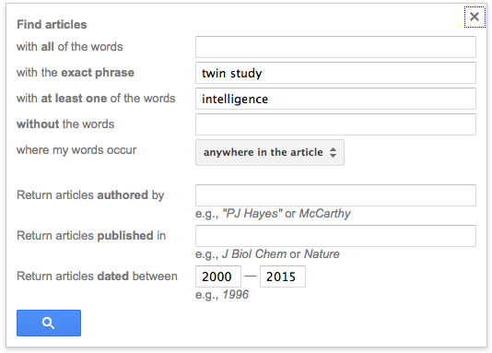

Dates are important for relevance

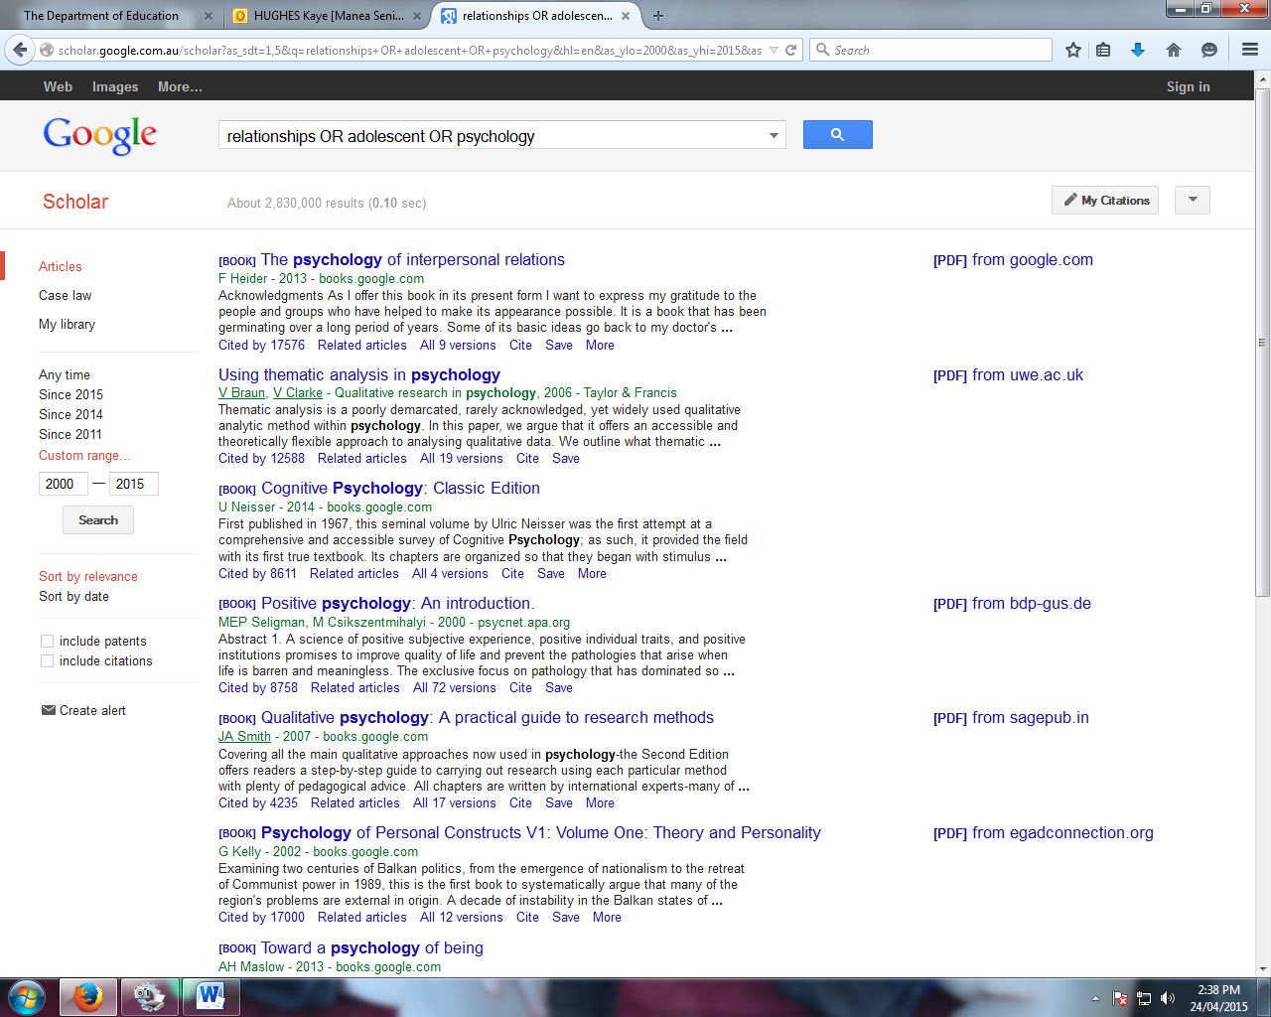Then hit the Search button.

* Untick these two boxes on the left hand side of your screen
* Any search result with a .pdf link on the right hand side is an article. Consider going past the first few pages or adding a keyword in your search to narrow down an article specific to your interest. Don’t use a book!

Make sure you print and reference your article. Please download and save the article before you use/read it. Use the following pages to complete your task.

*Title of Journal Article* Literature Review

Task One

*Your Full Name*

ATAR Psychology Year 11 | Unit 2

Mr Anthony Britza

Tranby College

**Literature Review Sheet Name:**

Document Title:

1 mark

Document reference (use APA)

2 marks

|  |
| --- |
| What evidence is there that the author is qualified to discuss this topic? Are the person’s qualifications relevant to the topic?  1 mark |

|  |
| --- |
| What are the **sources** of the author’s information? Experiment details - describe the study  3 marks |

|  |
| --- |
| Does the article contain all of the sections expected for scientific report/article? – Abstract, Intro, Method, Results, Discussion, Conclusion (sometimes), References  2 marks |

|  |
| --- |
| Who published this document and is the information current? Is the article from a peer-reviewed journal? (How old is it? Usually current articles are within 10 years)  2 marks |

|  |
| --- |
| In the discussion section – does the article address implications for the future (practical implications) and limitations of their research?  3 marks |

|  |
| --- |
| Is the article about a new experiment or a re-test of an older one?  1 mark |

|  |
| --- |
| DATA - How big was the sample size? Is it a reliability and validity sample?  2 marks |

|  |
| --- |
| What is the document about? (Briefly summarise the main ideas in the document using words or a concept map.)  2 marks |

|  |
| --- |
| Explain how the document is relevant to the Nature and Nurture debate surrounding intelligence?  1 mark |

|  |
| --- |
| What is the most interesting thing you learned from the document?  1 mark |

|  |
| --- |
| Please rate the document in terms of its usefulness as a resource for other students in your class. Write a statement to explain the reason for your rating.  [__________[__________[__________[__________]  5 4 3 2 1  Very Useful Uncertain Minimal No use  useful use  Explanation of rating  2 marks |

|  |
| --- |
| **Any other comments/information:**  1 mark |

**\*\*\* Attach a copy of your document with this review. No document = No marks.**